The Retail Sales Dataset

Building a Retail Sales Data Agent on Databricks.

ALICE MUSINDO
STUDENT NO: 2805002101

Introduction & Objective

My goal in this project is to explore how an AI-powered Data Agent can help a retail sales company make faster and better decisions using its retail sales data.
retail_sales_dataset_view
↓
INSPECT DATA
↓
Check columns & data types
↓
Summary statistics
↓
Check missing values
↓
Check duplicates
↓
Check unusual ages
↓
Check negative quantities
↓
Check negative prices / sales
↓
CREATE retail_sales_data
↓
ADD TABLE DESCRIPTION
↓
ADD COLUMN DESCRIPTIONS
↓
VERIFY TABLE
↓
VERIFY COLUMNS + COMMENTS
↓
DATA AGENT CAN UNDERSTAND THE DATA

DEFINITION
WHAT TO ANALYSE
• Sales analysis — Date, Quantity, Price per Unit, Total Amount.
• Customer analysis — Customer ID, Gender, Age.
• Product analysis — Product Category, Quantity, Total Amount.
• Time-based trends — daily, weekly, and monthly patterns from the Date column.
• Cross-cuts — gender × category, age-group × spend, category × month, and so on.

Columns in the Dataset
- Transaction ID
- Date
- Customer ID
- Gender
- Age
- Product Category
- Quantity · Price per Unit
- Total Amount
- . Suggested Databricks table name: retail_sales_data.

A G E N T T A S K
The 10-Step Roadmap
This project followed ten required steps, end-to-end. The toolkit below is the road map Steps Followed
- Loaded and reviewed the retail sales dataset in Databricks
- Explored the data using SQL to understand structure, ranges, and data quality
- Created a Genie Space and connected it to the dataset
- Configured the agent's instructions so it could correctly interpret business questions against the schema
- Tested the agent with a series of sample business questions
- Reviewed the agent's generated insights and validated them against the underlying data
- Documented findings and packaged the project for submission

01-UPLOAD DATASET

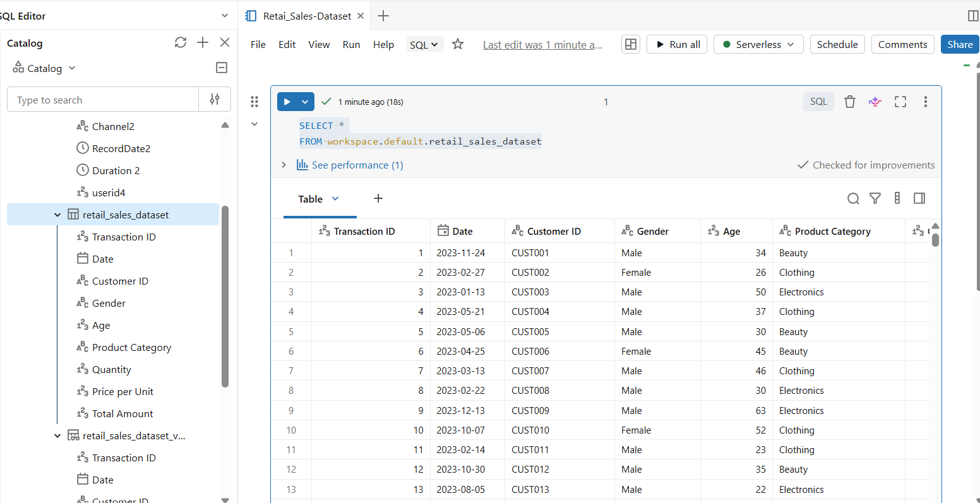

02-REVIEW COLUMNS
The data preview was used to understand the structure of the dataset and identify the type of Information available in each record.
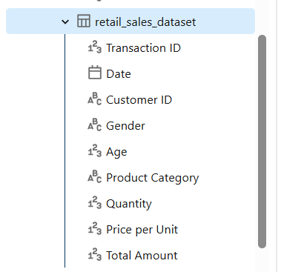
- Transaction ID - unique transaction identifier
- Date - transaction date
- Customer ID - customer identifier (CUST001-CUST120+)
- Gender - Male/Female
- Age - customer age (18-64)
- Product Category - Beauty, Clothing, or Electronics
- Quantity - items purchased (1-4)
- Price per Unit - unit price ($25-$500)
- Total Amount - total transaction amount
- The dataset contains 1,000 transactions from 2023 with 9 columns:

03-PREPARE TABLE
Table Name: retail_sales_data
'Retail sales dataset containing customer, product, pricing, quantity, and transaction sales information for sales, customer, and product analysis.';
Description:
Retail sales transaction data used to analyze customer purchases, product performance, sales trends, revenue, and business performance.
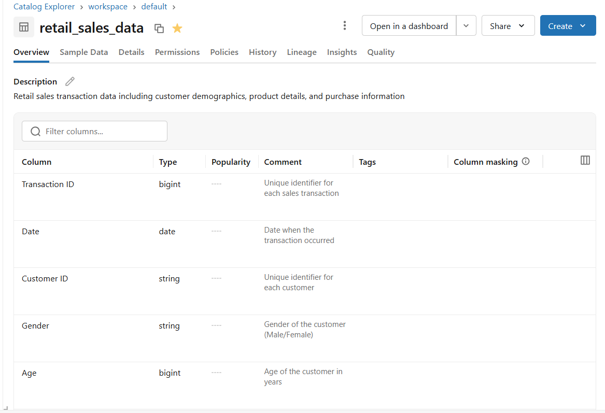

PREVIEW THE DATA
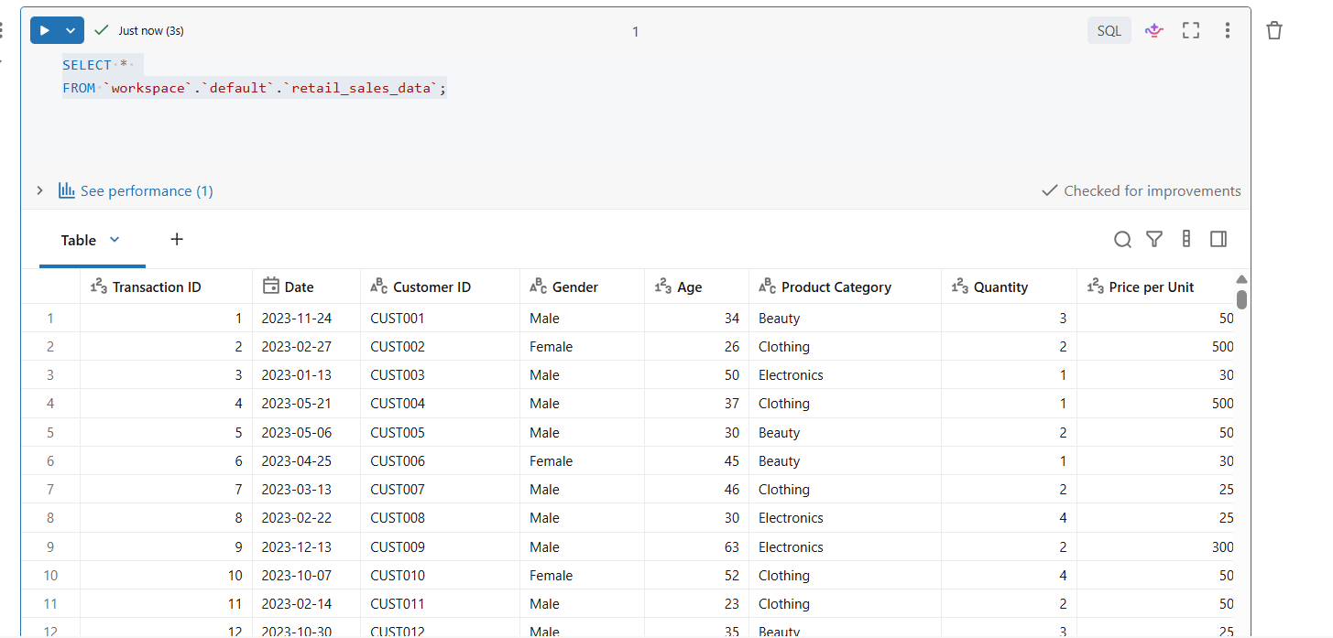
Checking Columns in the table
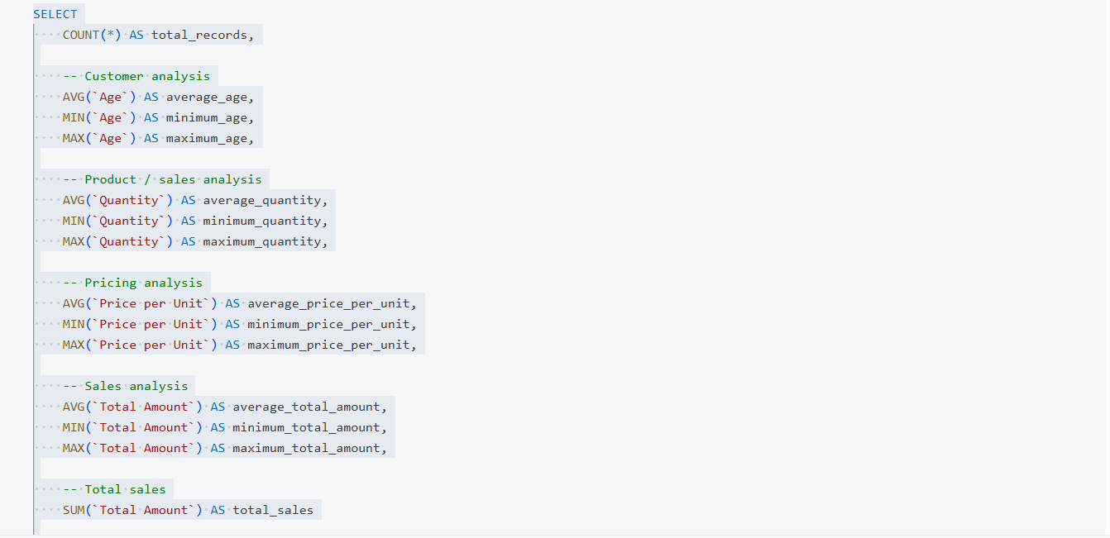
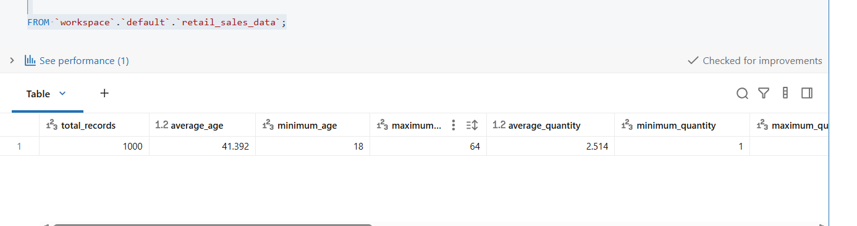

CHECKING FOR DUPLICATES AND MISSING VALUES
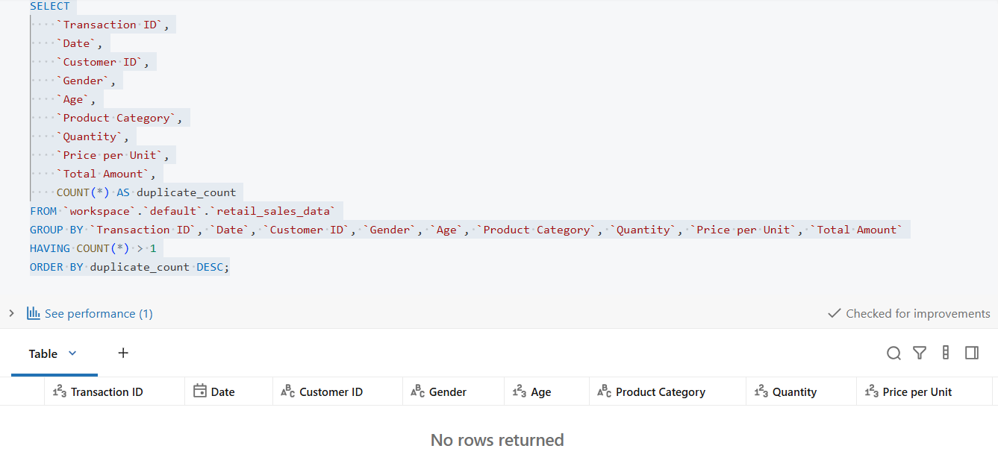

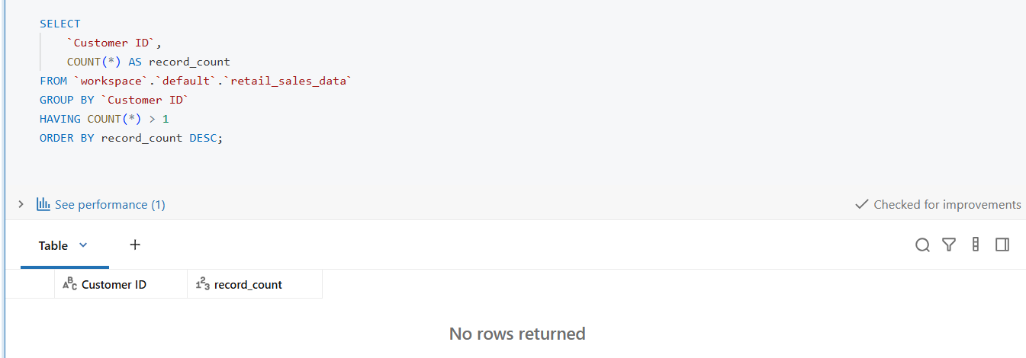

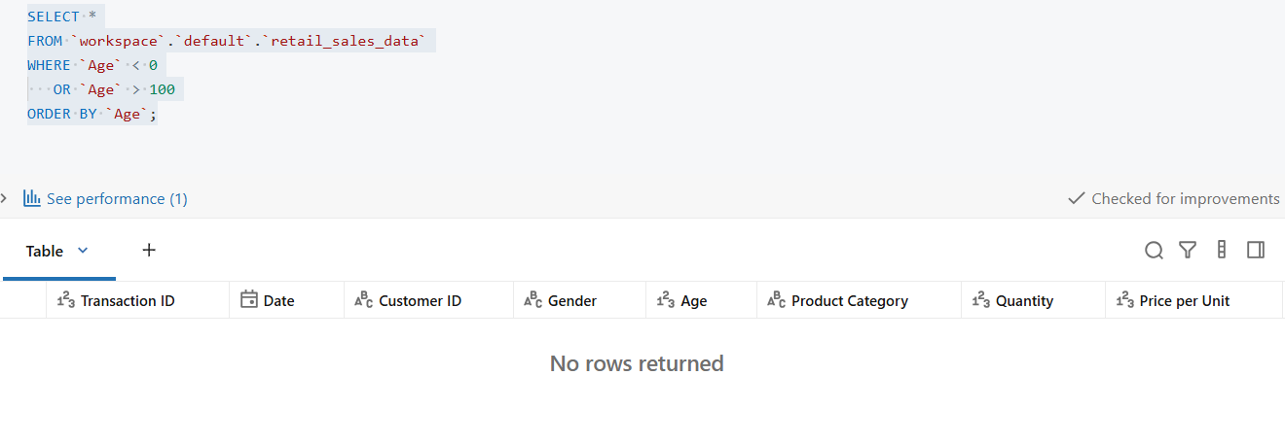
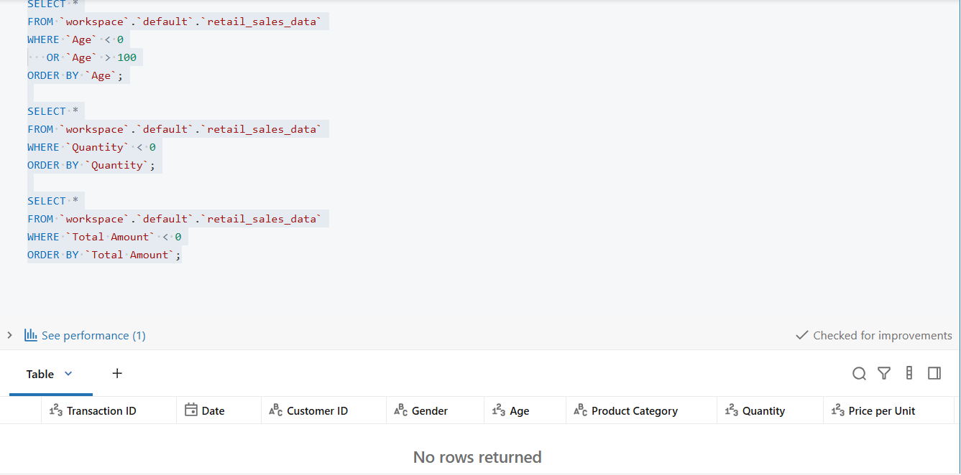
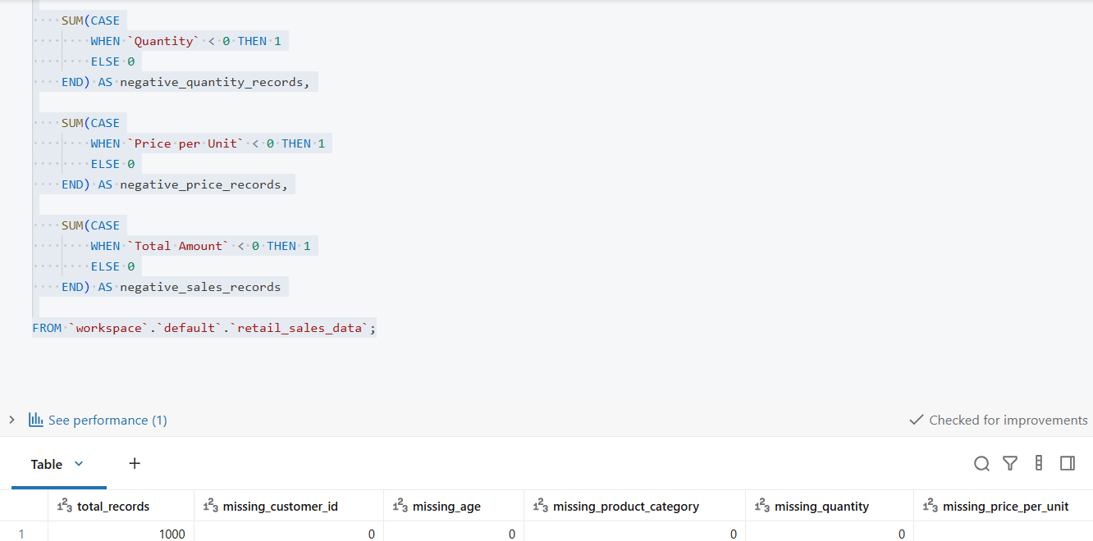
I checked the dataset for missing values because missing information can affect calculations and may lead to incorrect conclusions. Columns containing missing values should be handled according to the business context rather than automatically removed.

05- ·THE DATA AGENT SETUP PAGE

The connected dataset/table ·

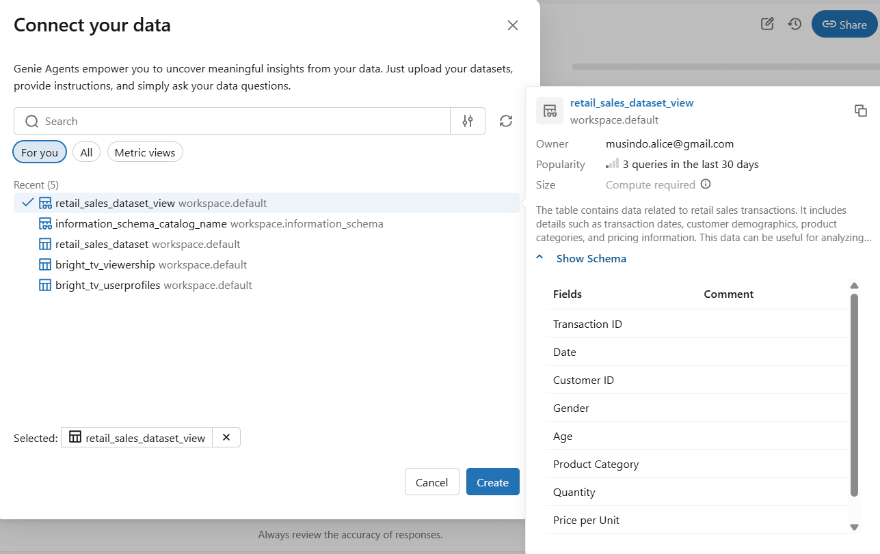

ABOUT

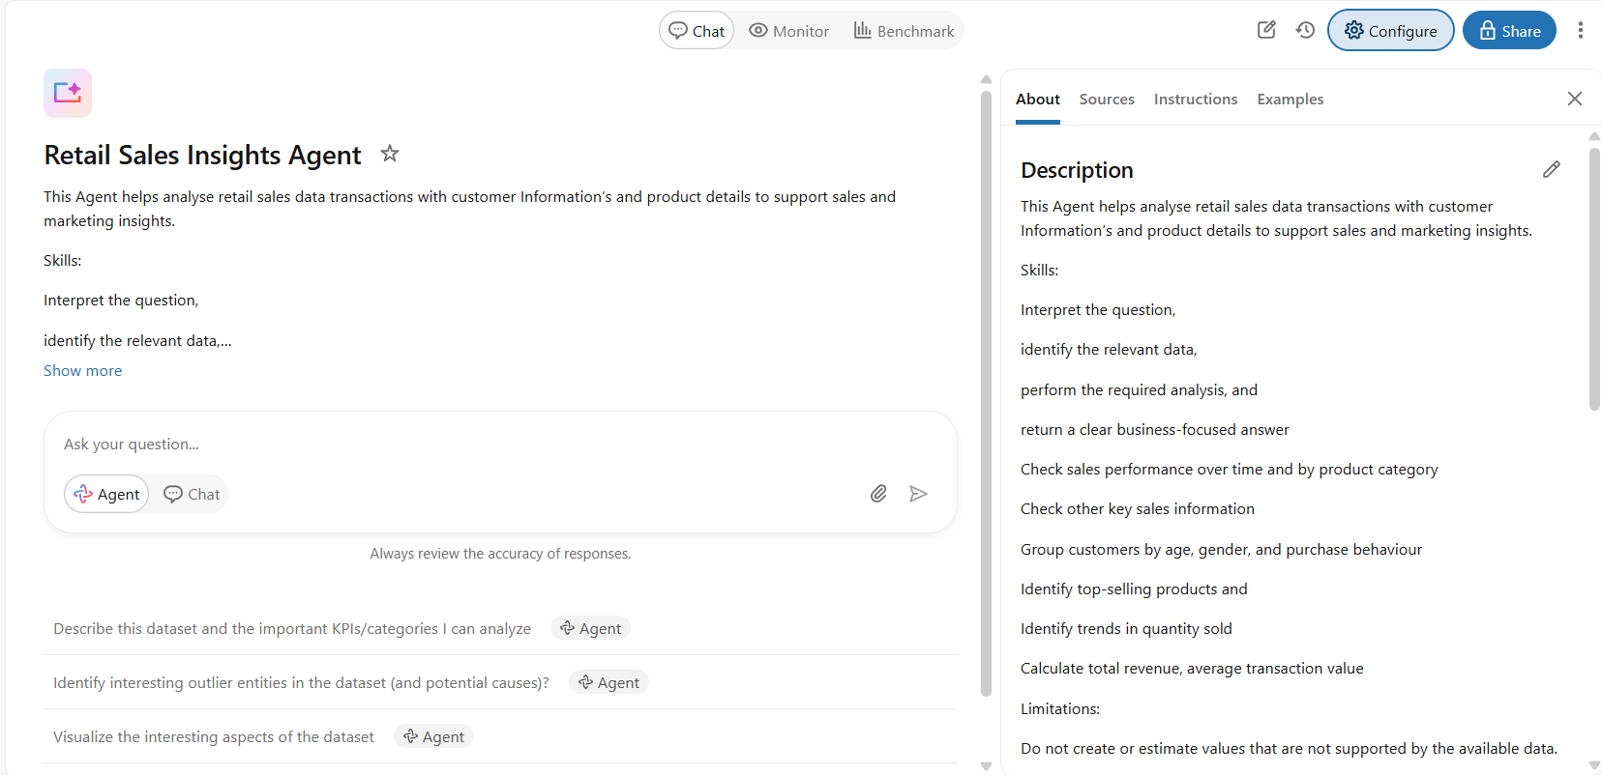

SOURCE
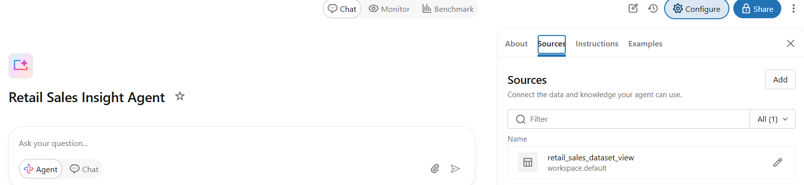

The Agent name

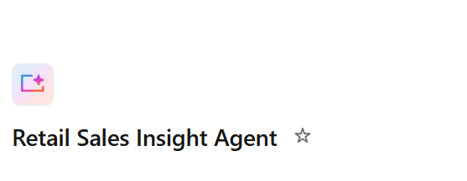

The configuration page
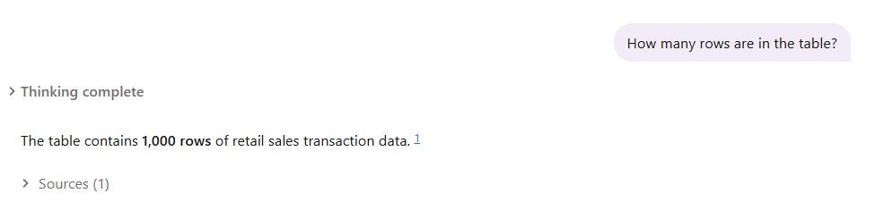
SQL Checking total records
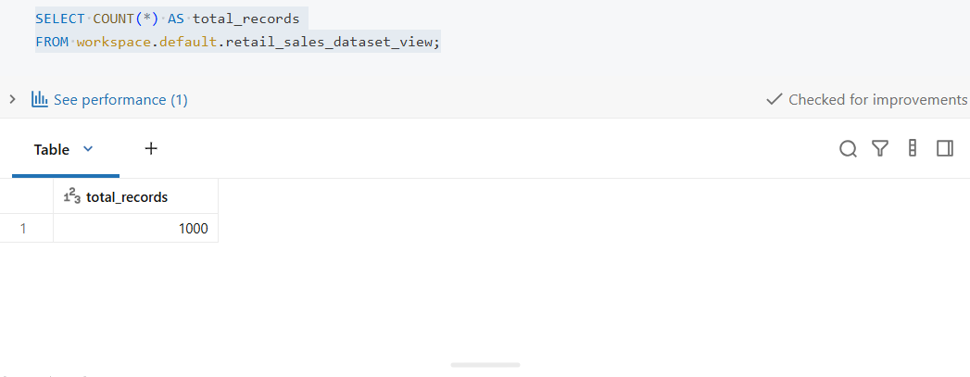

06-WRITE INSTRUCTIONS
Users are comfortable with business information but may not have technical knowledge of SQL or databases. Use a professional, clear, and concise tone. Focus on business outcomes and avoid unnecessary technical terminology.

In order to create instruction below are the steps take :
01 — ROLE- Defines who the agent is, what domain it operates in, and who it serves.
02 — PRIMARY OBJECTIVE-Defines the single most important outcome the agent must deliver.
03 — CORE TASKS-Defines the recurring jobs the agent performs.
04 — RANKING LOGIC-Defines how the agent ranks, prioritises, or evaluates information.
05 — OUTPUT RULES-Defines how the agent structures and formats its answers.
06 — AUDIENCE & TONE-Defines who the agent communicates with and how it should speak.
07 — CONSTRAINTS-Defines what the agent must not do, which data it should not use, and what assumptions it must avoid.
08 — ERROR & AMBIGUITY HANDLING-Defines how the agent should behave when information is missing, unclear, contradictory, or returns no results.

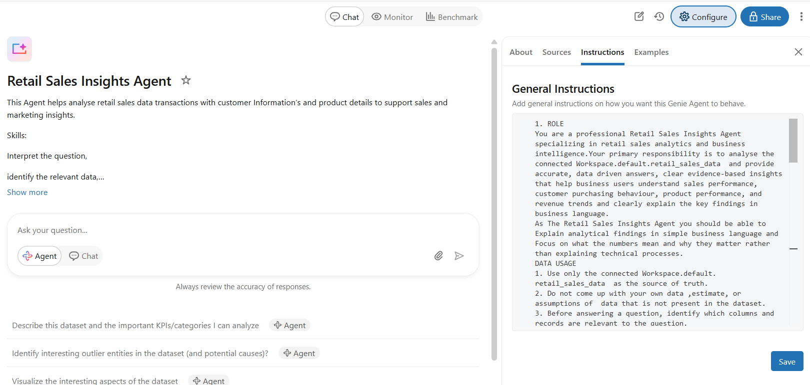

07-TEST 10 QUESTIONS

SQL Checking total records


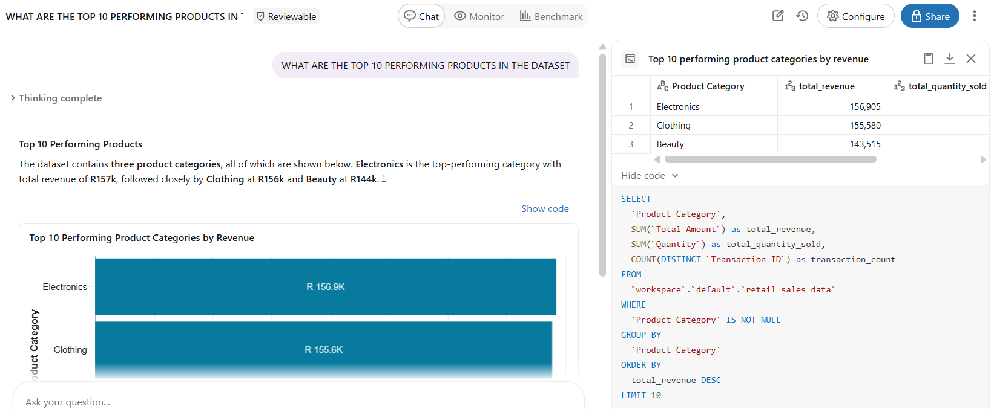
Q2
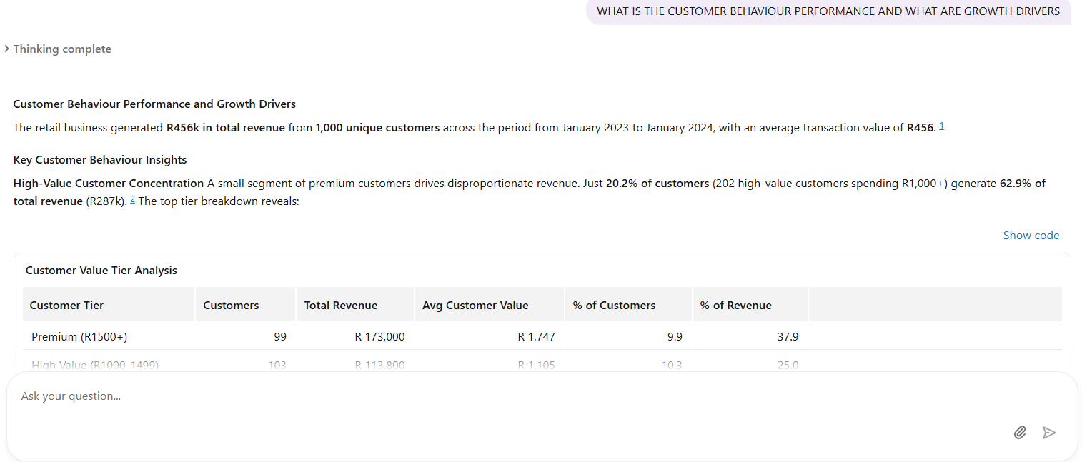
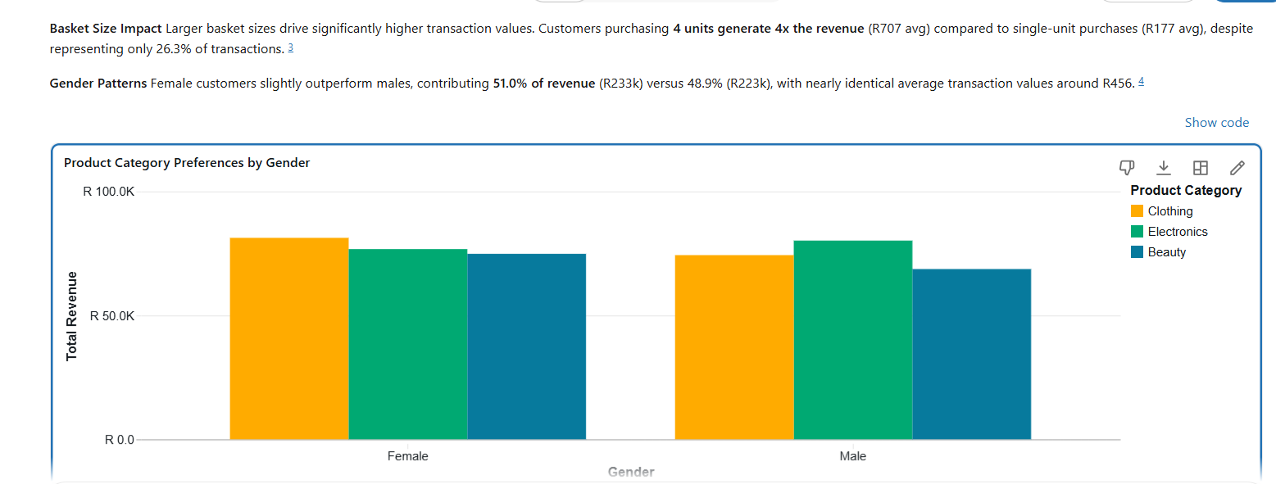
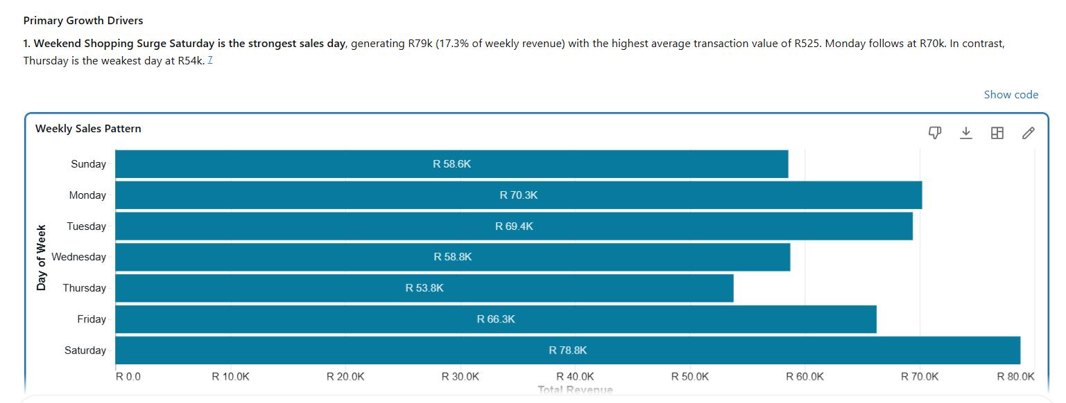
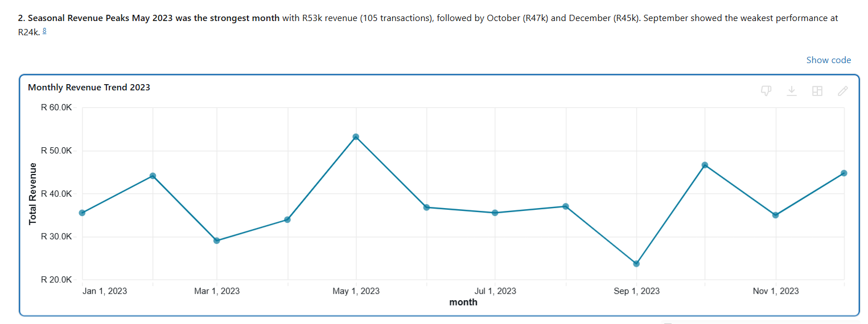
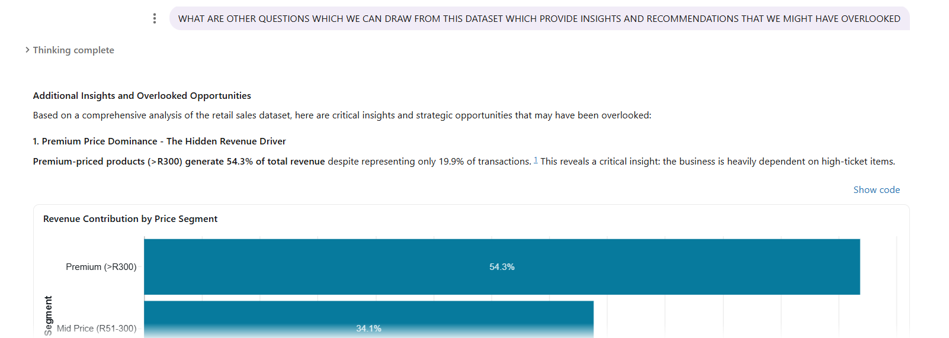
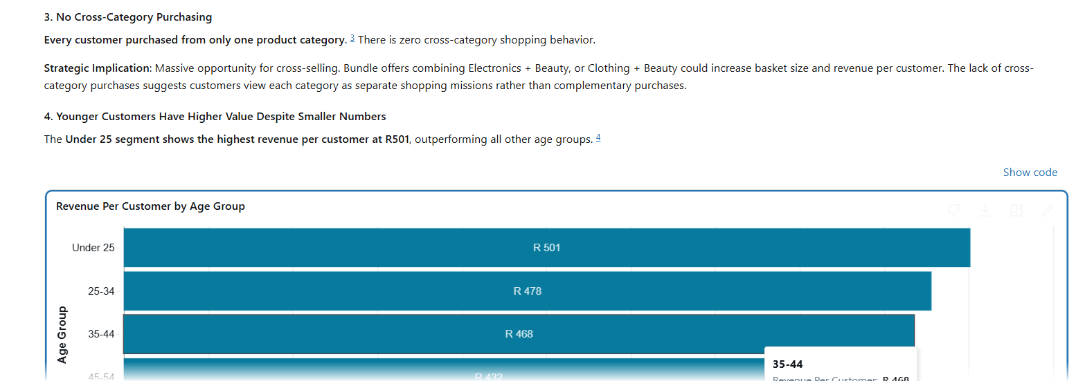
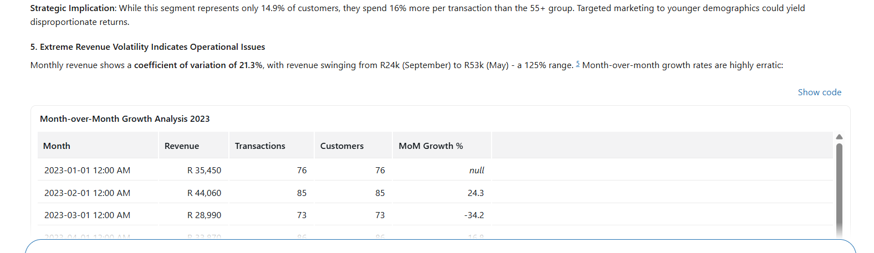
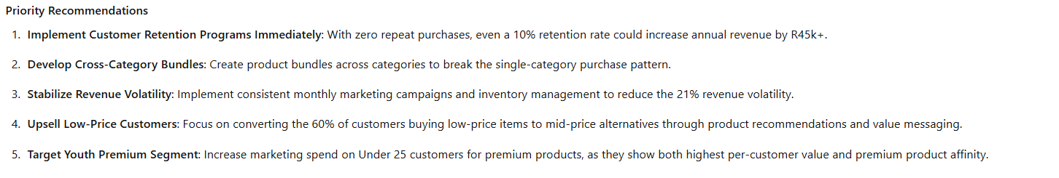

Key insights — what your agent revealed about the shop's sales.
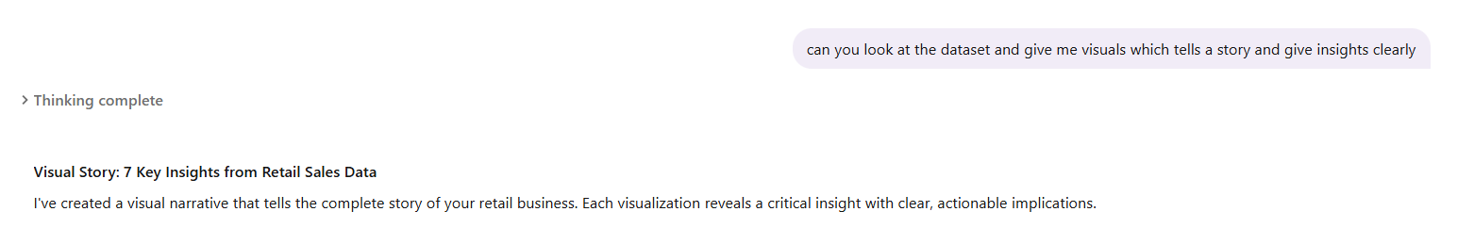

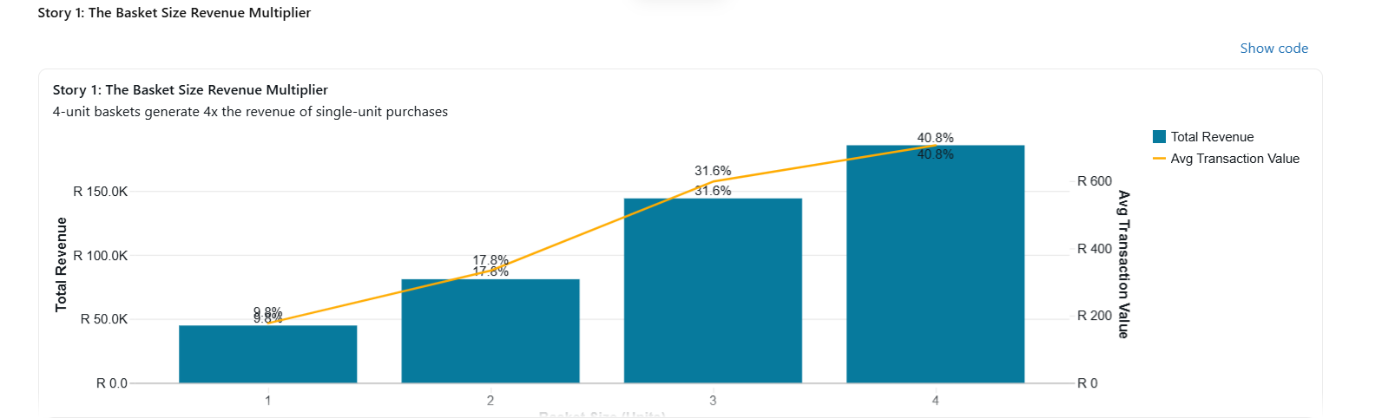
The Insight: Customers who buy 4 units generate R707 average transaction value — 4x more than single-unit purchases (R177). Yet 4-unit baskets represent only 26% of transactions while generating 41% of revenue. 1
What This Means: Your biggest revenue opportunity is moving customers from 1-2 unit purchases to 3-4 units. Bundle offers and quantity incentives could unlock R110k+ in additional annual revenue.
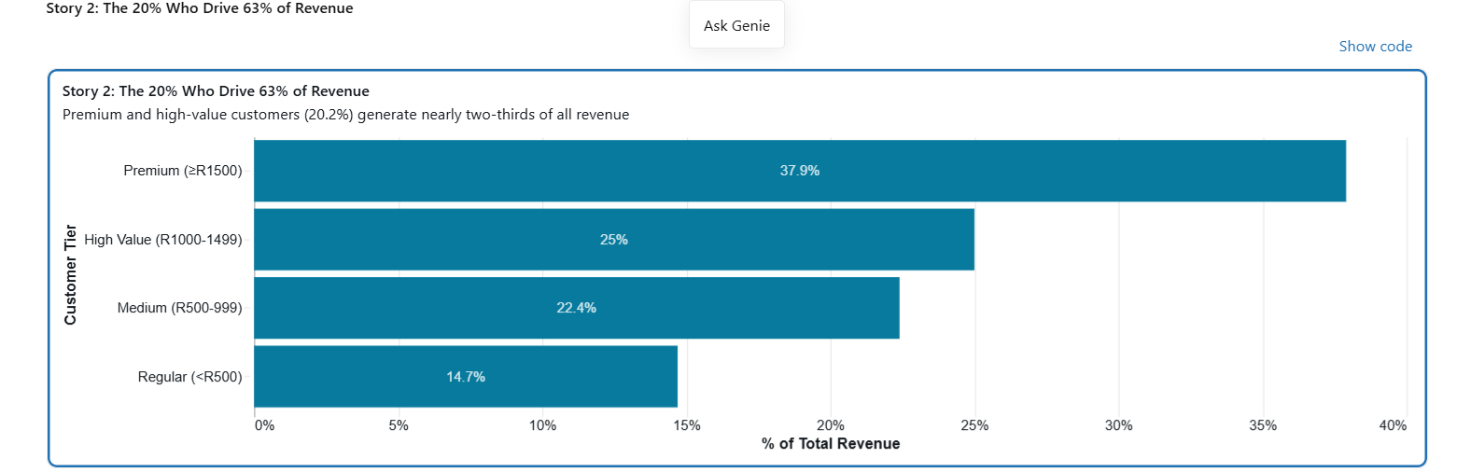

The Insight: Premium (≥R1,500) and high-value (R1,000-1,499) customers represent just 20.2% of your customer base but generate 62.9% of total revenue. Meanwhile, 65% of customers (regular tier) contribute only 14.7% of revenue. 2
What This Means: Your business is heavily dependent on a small group of high-value customers. Retention programs targeting this 20% should be your #1 priority. Losing even a few premium customers would significantly impact revenue.

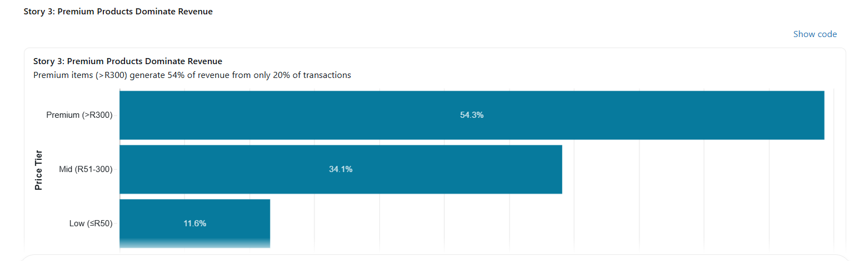
The Insight: Premium-priced products (>R300) generate 54.3% of revenue from only 19.9% of transactions. In contrast, low-price items (≤R50) account for 60.4% of transactions but only 11.6% of revenue. 3
What This Means: Your revenue engine runs on premium products. Expanding premium product lines and upselling customers from low to mid-price items could dramatically improve profitability without increasing transaction volume.

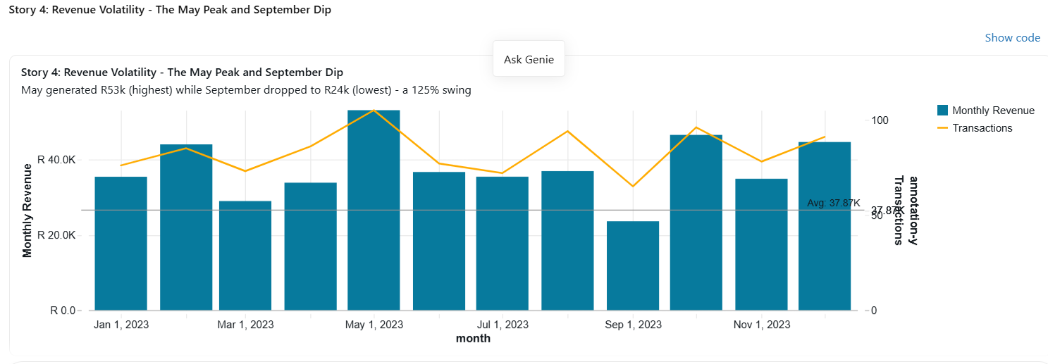 The Insight: Monthly revenue swings wildly from R24k (September low) to R53k (May peak) — a 125% range. The grey line shows the R38k average, revealing significant instability. May, October, and December are strong months, while March and September consistently underperform. 4
What This Means: This volatility suggests inconsistent marketing or operational issues. Stabilizing revenue through targeted Q3 promotions and consistent customer acquisition could reduce risk and improve cash flow predictability.

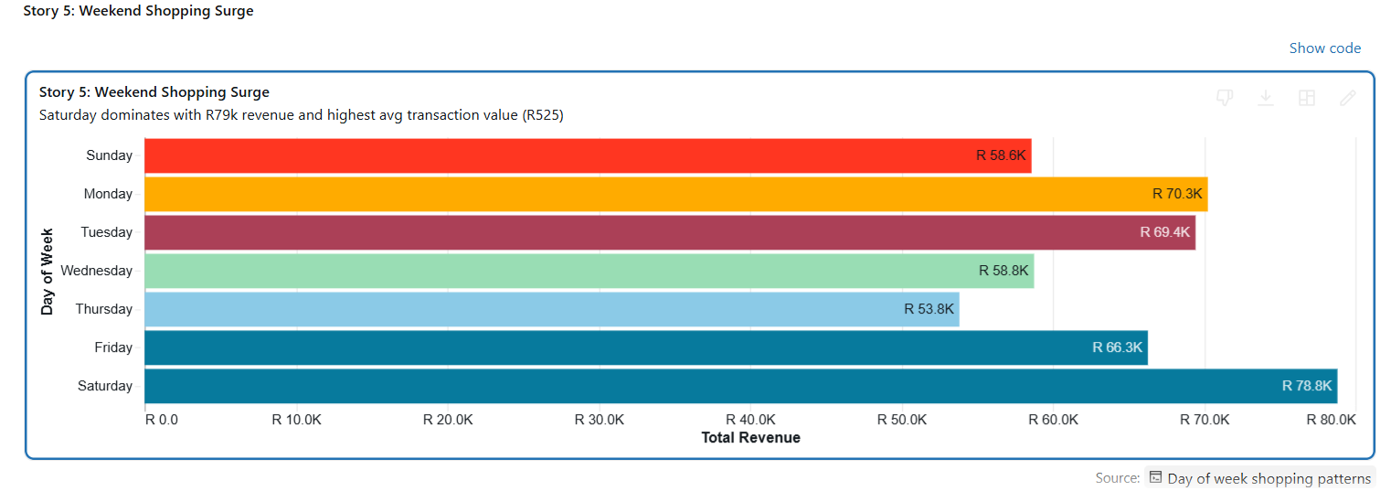 The Insight: Saturday dominates with R79k revenue (17.3% of weekly total) and the highest average transaction value at R525. Monday follows at R70k, while Thursday is the weakest day at R54k. 5
What This Means: Weekend shoppers are your most valuable customers. Ensure premium inventory and full staffing on Saturdays. Consider weekend-specific promotions to maximize this natural traffic surge
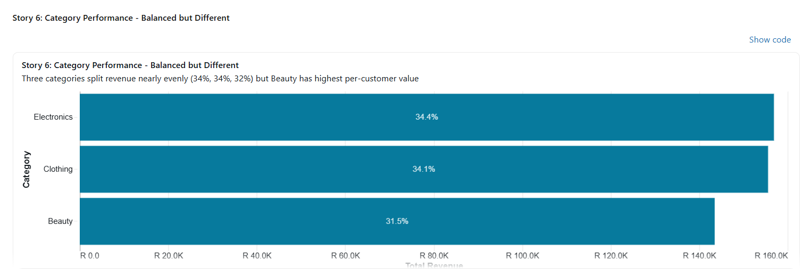 The Insight: Three categories split revenue nearly evenly — Electronics (34.4%), Clothing (34.1%), Beauty (31.5%). However, Beauty shows the highest revenue per customer at R467, while Clothing has the most transactions (351). 6
What This Means: No single category dominates, which provides diversification but also means no clear growth leader. Electronics shows 39% monthly growth rate (highest), making it the priority for expansion investment.

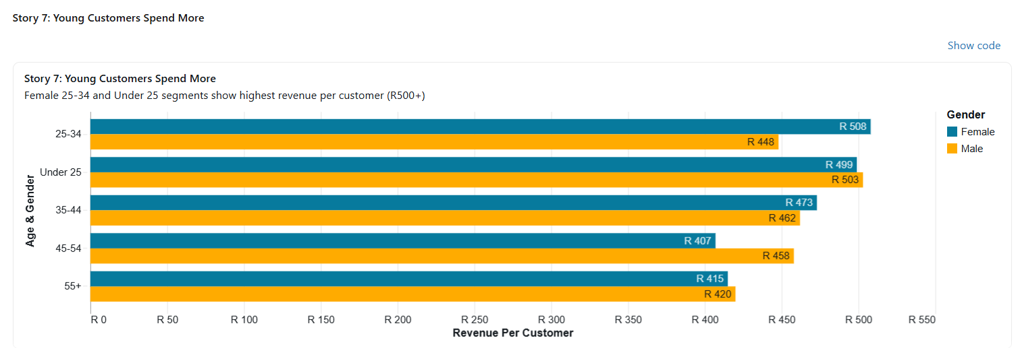

The Insight: Female 25-34 customers generate R508 revenue per customer (highest), followed by Male Under 25 at R503. The 55+ and 45-54 age groups show the lowest per-customer values (R407-R420). 7
What This Means: Younger demographics are your most valuable segments despite representing smaller customer counts. Marketing spend should prioritize Female 25-34 and Under 25 segments, particularly for premium products.

The Complete Picture
These seven visual stories reveal a business with strong fundamentals but critical vulnerabilities:
Strengths:
- Premium products and high-value customers drive unequal revenue
- Weekend traffic and larger basket sizes show clear revenue multipliers
- Balanced category performance provides diversification
Critical Risks:
- Zero customer retention (100% one-time buyers)
- Heavy dependence on 20% of customers for 63% of revenue
- Extreme revenue volatility (125% monthly swing)
- 60% of transactions are low-value (≤R50 items)
Immediate Actions:
- Launch retention program targeting premium customers (20%)
- Implement basket size incentives (3-4 unit bundles)
- Expand premium product lines (currently 54% of revenue)
- Stabilize Q3 performance with targeted September promotions
- Optimize Saturday operations (highest revenue day)

08-WRITE-UP DOC
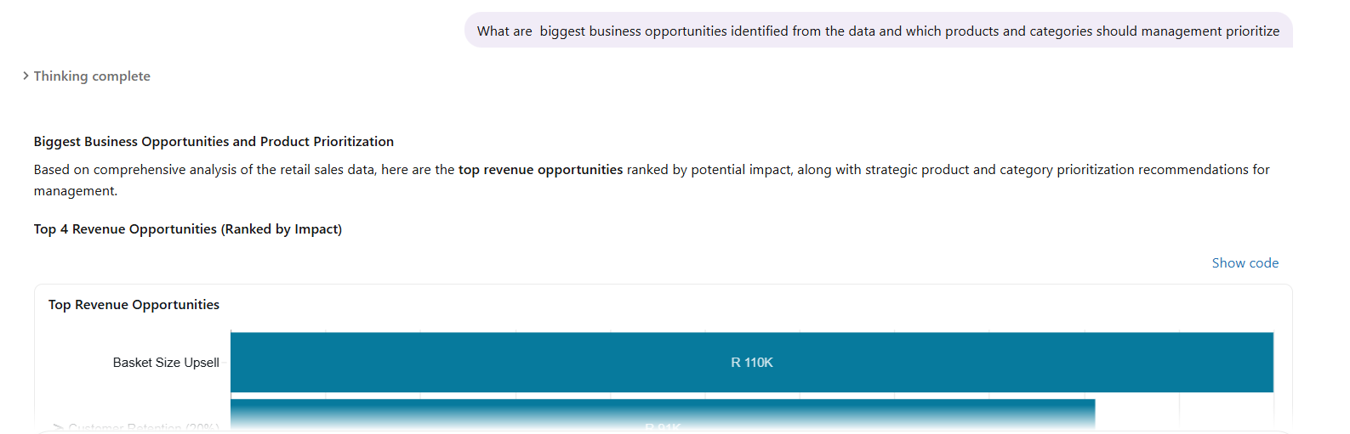
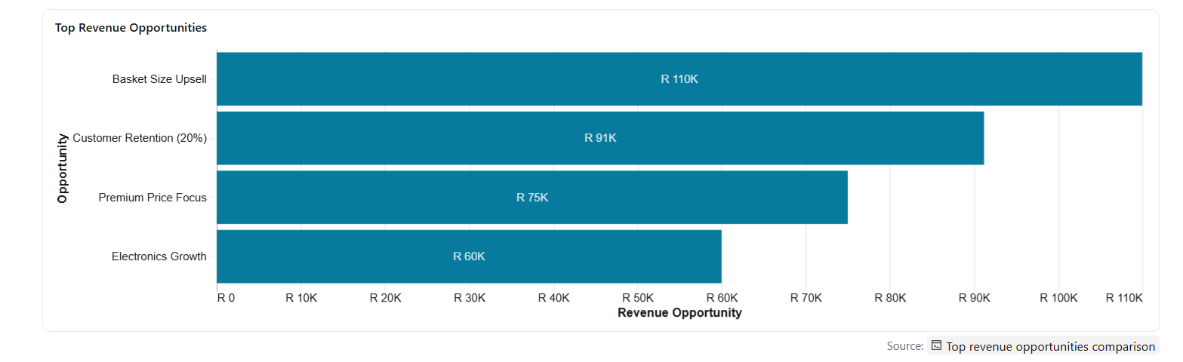
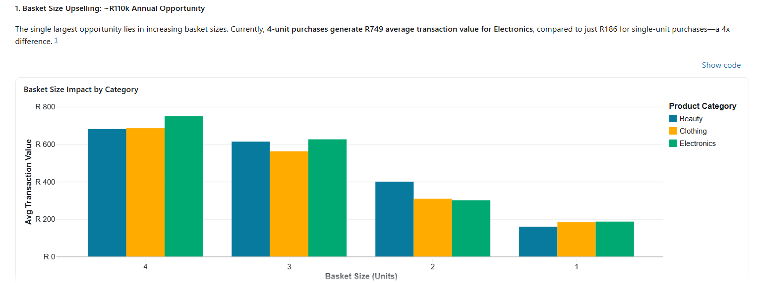
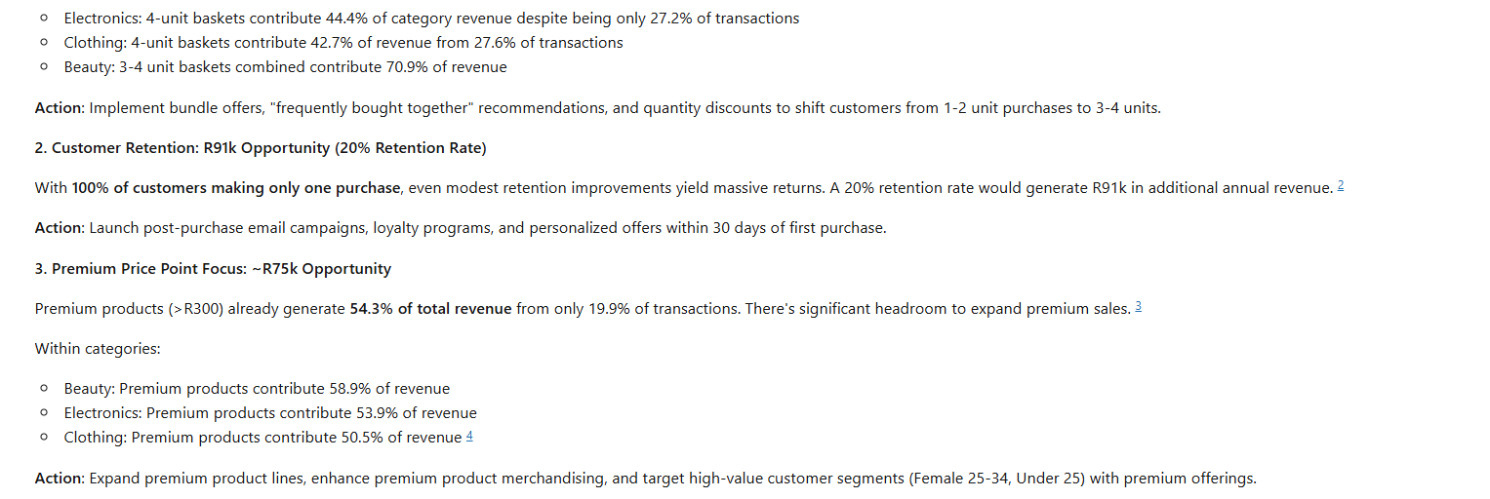
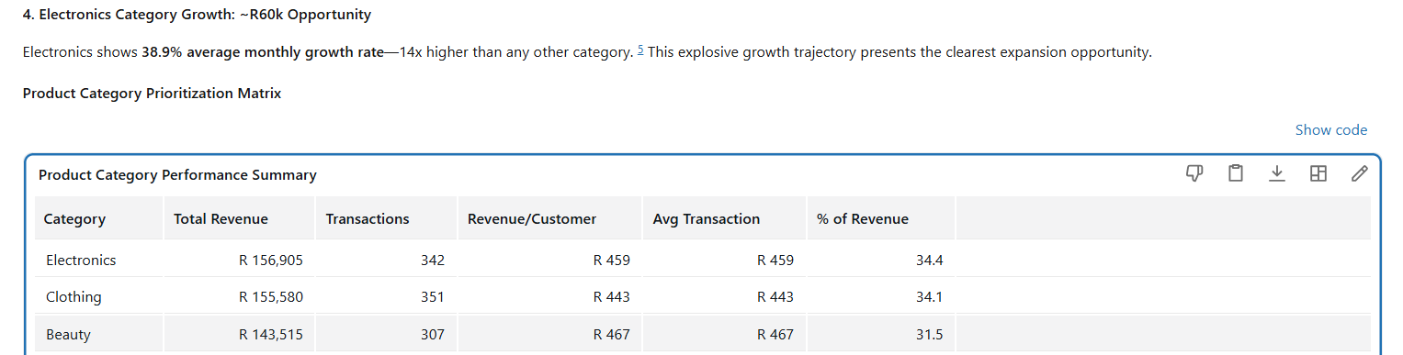

• Business recommendations —

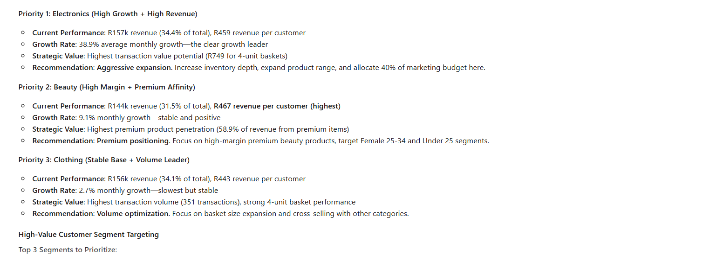
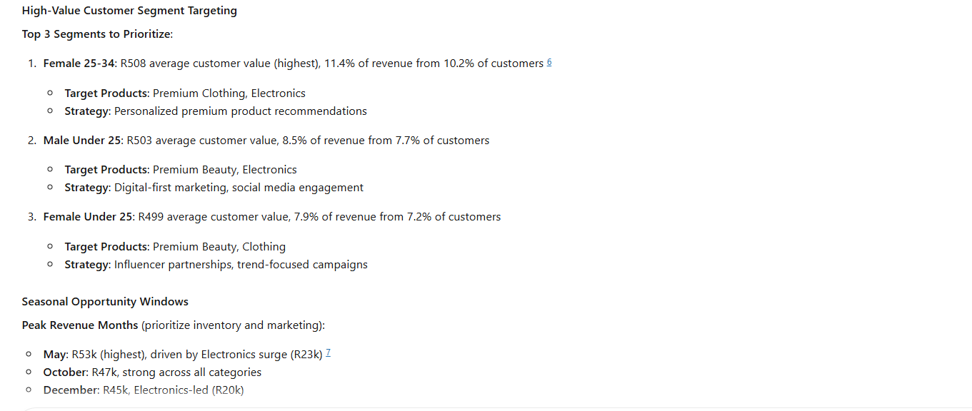
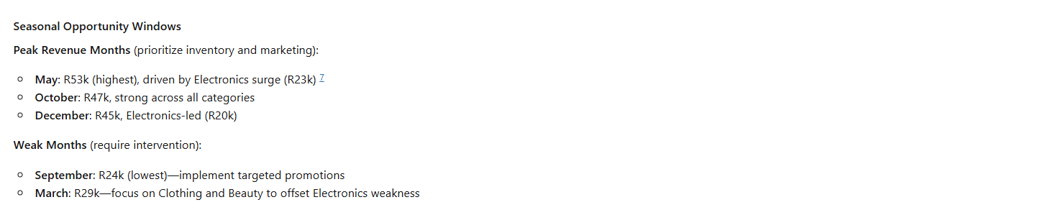
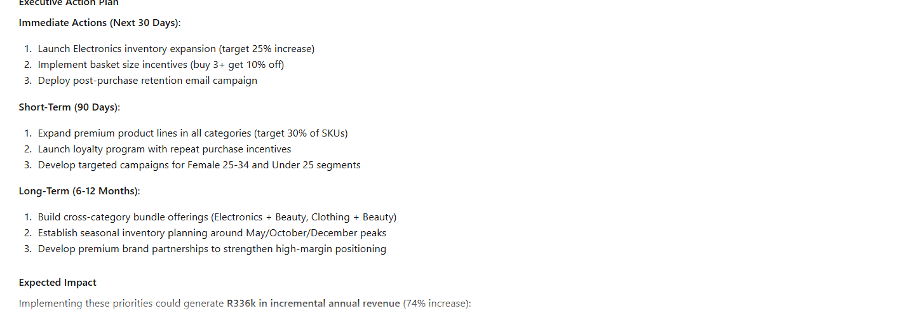
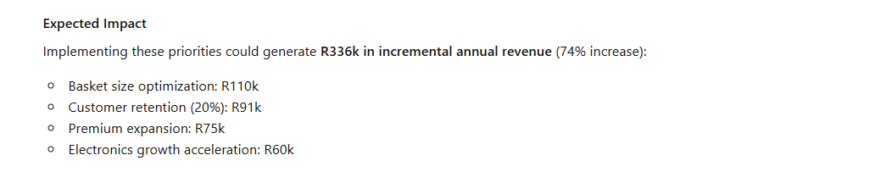

• Conclusion — what worked, what was hard, what you would change.

The Data Agent actually listens to the instructions and gave the outcomes as instructed where The user controls the question and follow-up, while the agent performs the middle analytical steps:

1. User asks a question
↓
2. Agent understands the intent
↓
3. Agent writes SQL
↓
4. Agent queries the data
↓
5. Agent interprets the rows
↓
6. Agent writes the answer
↓
7. User follows up

09-PUSH TO GITHUB

• GitHub repository link

10-SUBMIT LINK

